Application Number | 07/2016/0310/OUT
Address | Land To The North of Altcar Lane Leyland
Applicant | Homes and Communities Agency
Proposal | To vary the Section 106 agreement associated with this site to provide for 30% affordable housing units as part of a Deed of Variation.
Officer Recommendation | That Members note the report and be minded to support the supplementary Deed of Variation and that the details be delegated to the Planning Manager in consultation with the Chair and Vice-Chair of the Planning Committee upon the successful completion of the Deed of Variation to secure proposed level of affordable housing.
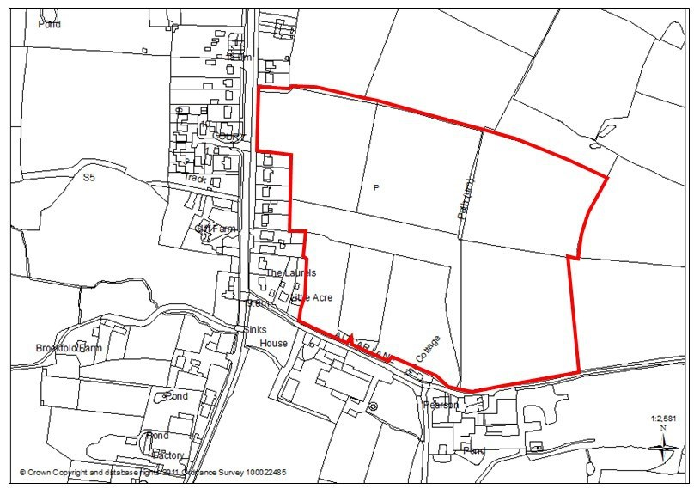

1.0 Report Summary
1.1 Planning permission has been granted for the construction of up to 200 dwellings on part of land at Altcar Lane. A Section 106 agreement relates to the site which secured 40% of the dwellings to be part of the Government Initiative known as Starter Homes.

1.2 As Starter Homes are unlikely to come forward the applicant is seeking to amend the Section 106 to reflect this change. Instead the development would provide 30% Affordable Housing Units and as such meets the aims of Policy 7 of the Central Lancashire Core Strategy.

1.3 Therefore, the officer recommendation is to approve the changes to the Section 106 agreement through a Deed of Variation.

2.0 Site and Surrounding Area
2.1 The application site is located approximately 2km south of Leyland town centre on land to the north of Altcar Lane, Leyland. To the north and east lies agricultural land which is allocated for housing. Altcar Lane forms the southern boundary with open countryside beyond. The rear gardens of properties on Leyland Lane and Altcar Lane form the western boundary.

3.0 Planning History
3.1 The site forms part of a wider allocation and is identified within the South Ribble Local Plan 2015 as subject to Policy D1 which allocates sites for new housing and is referenced as Site “P” land between Altcar Lane/Shaw Brook Road, Leyland.
3.2 A Masterplan was prepared jointly with the Homes and Community Agency (HCA) and Redrow Homes, and approved in March 2016 for Development Management Purposes.
3.3 Two outline planning applications have been approved for the site and are both the subject of separate Section 106 agreements.
3.4 HCA Site: 07/2016/0310/OUT - Outline application for a residential development (approx 200 dwellings) with access off Leyland Lane (Access applied for) - Land North of Altcar Lane, Leyland. Approved February 2017.
4.0 Proposal
4.1 Planning permission has been granted for 200 units on land to the north of Altcar Lane. The planning committee report advised that the site would deliver an increased amount of affordable provision 40% instead of 30% through the Starter Homes initiative as set out in the Housing and Planning Act 2016. However, this government initiative is no longer due to come forward and on that basis the applicant seeks to amend the Section 106 agreement to reflect this change.

4.2 The amendment provides for an affordable housing scheme to be submitted to the Council based upon a total of 30% of affordable housing units to be delivered. The mix is set out below.

(a) 70 % Social Rented Housing Units; and
(b) 30% Shared Ownership Housing Units
5.0 Material Considerations

5.1 Policy

Central Lancashire Core Strategy
Policy 1: Locating Growth focuses growth and investment on brownfield sites in the main urban areas, whilst protecting the character of suburban and rural areas.

Policy 4: Housing Delivery provides for and manages the delivery of new housing. For South Ribble this amounts to 417 dwelling pa.
Policy 7: Affordable Housing seeks to ensure sufficient provision of affordable and special housing to meet needs.

5.2 South Ribble Local Plan 2012-2026

5.3 Supplementary Planning Documents
- Affordable Housing

6.0 Other Material Considerations

6.1 Affordable Housing
The Housing and Planning Act 2016 provided the statutory framework for the delivery of starter homes, with the aim to make new build houses available to first time buyers under 40 at a discount of at least 20 per cent of full market value.
A document entitled Starter Homes Regulations: Technical Consultation sought views on the details of the regulations which raised a number of concerns. Specific concerns were raised about the mandatory 20 per cent requirement which would have displaced most of the developer contributions for traditional forms of affordable housing. The Government has listened to these concerns and further consultation and changes may come forward.
Therefore, the Homes and Community Agency can no longer deliver the Starter Homes as originally envisaged and seek a variation to the Section 106 Agreement so that there revised proposals are compliant with the Council’s affordable housing policies.
Policy 7 of the Core Strategy is entitled Affordable Housing and states that a target of 30% affordable housing provision is to be sought on new housing schemes on urban sites.
The Central Lancashire Affordable Housing SPD at paragraph 9 states that “The definition of affordable Housing Affordable is set out in annex 2 of the National Planning Policy Framework. It includes Social Rented, Affordable Rented and Intermediate housing provided to eligible households whose needs are not met by the market.”
Consultation has taken place with the Strategic Housing Team who has advised that 30% affordable housing to be provided on-site would meet policy requirements (Policy 7 of the Central Lancashire Core Strategy).

The proposed change would support affordable home ownership in Leyland and therefore the amendment proposed by the Deed of Variation is considered Policy Compliant and acceptable.

7.0 CONCLUSION
The delivery of this site for residential development supports the aims and objectives of the Lancashire, Preston and South Ribble City Deal. The proposed Deed of Variation which would provide for 30% of the residential units to be affordable is acceptable.

8.0 RECOMMENDATION
That Members note the report and be minded to support the changes associated with the delivery of 30% affordable housing units to the Deed of Variation and that the decision be delegated to the Planning Manager in consultation with the Chair and Vice-Chair of the Planning Committee upon the successful completion of the details within the Deed of Variation.

